**Individual project definition and research proposal**

**C17000**

**Kingsley Ugonna Aguagwa**

**K2363903**

**Integrated Telehealth and E-clinic platform for Patient Management**

**16TH July 2024**

Table of Contents

Abstract 4

Chapter 1 5

Introduction 5

1.1 Background 5

1.2 The Stakeholders 5

1.3 Problem Statement 6

1.4 Importance of the Project 6

1.5 Benefits for stakeholders 7

1.6 Relation to Previous Work and Existing Knowledge 7

1.7 Aims 7

1.8 Objectives 8

1.9 Intermediate or Enabling Deliverables 9

CHAPTER 2 11

Literature Review 11

2.1 Introduction 11

2.2 Telehealth 11

2.3 E-clinics and Electronic Health Records (EHRs) 11

2.4 Integrating Telehealth and E-clinic Platforms 12

2.5 Data protection and privacy 14

2.6 User Interface Design 14

2.7 Related Work and Existing Platforms 14

2.8 Conclusion 15

Chapter 3 16

Technologies and Resources 16

3.1 Major Resources Required 16

3.3 Software & Tools 16

3.4 Human Resources 16

3.5 Technologies to be used 18

3.5.1 Front End Technologies 18

3.5.2 Back-End Technology 18

3.5.3 Database 18

3.5.4 Security Technologies 18

3.6 Data Sources 18

3.7 Integration of Third-Party Services 19

Chapter 4 20

Method and Work plan 20

4.1 Methodologies 20

4.2 Milestones and deliverables 20

4.3 Additional Documentation 21

4.4 Major Contingencies 22

4.5 Risk Analysis 25

CHAPTER 5 28

Ethical, Legal, Data Protection, and Safety Aspects 28

5.1 Ethical Perspectives 28

5.2 Legal aspects 28

5.3 Data Protection Aspects 29

5.4 Safety considerations 30

Conclusion 30

References 32

# Abstract

This project aims to create an Integrated Telehealth and E-clinic Platform for Patient Management, addressing the fragmentation and inefficiencies of existing healthcare systems. The platform combines telehealth with e-clinic services, improving accessibility, efficiency, cost-effectiveness, continuity of treatment, and scalability. Key goals include creating a strong telehealth system, integrating electronic health records, improving patient management tools, ensuring data security and privacy, and providing training and support. The project will use agile approaches, incorporating ethical, legal, data protection, and safety issues to ensure regulatory compliance and excellent patient care standards. The project will use technology, software, and human resources, with a defined work plan outlining main phases, milestones, and deliverables.

# Chapter 1

# Introduction

The fast advancement of digital technology has drastically impacted the healthcare sector, prompting the development of innovative approaches aimed at improving patient care and management. One such innovation is the merging of telehealth and e-clinic platforms, which provide a more complete approach to treating patients. This project aims to provide an Integrated Telehealth and E-clinic Platform for Patient Management, meeting the rising need for efficient, accessible, and patient-centered healthcare services.

## 1.1 Background

The healthcare professionals (such as doctors, nurses, laboratory scientists and pharmacists), healthcare administrators, insurance firms, and legislators are among the various stakeholders in the healthcare business. Each of these stakeholders contributes significantly to healthcare delivery and administration.

## 1.2 The Stakeholders

1. **Patients:** The primary beneficiaries of the telehealth and e-clinic platform are those seeking accessible and convenient healthcare services.
2. **Healthcare providers:** Doctors, pharmacists, laboratory scientists, and nurses who provide treatment require effective tools for managing patient data and interactions.
3. **Healthcare administrators:** Individuals in charge of managing healthcare facilitate seeking methods to increase operational efficiency and patient satisfaction.
4. **Insurance Companies:** Entities that require accurate and timely patient data to file claims and provide covered services.
5. **Policymakers:** Government and regulatory authorities worked to ensure that healthcare services met high standards and were available to all population segments.

1.3 Problem Statement  
The fundamental issue addressed by this project is the fragmentation and inefficiencies of present healthcare delivery systems, which frequently result in delayed care, higher expenditures, and poor patient outcomes. Traditional healthcare approaches, which rely on face-to-face contacts, can be restricted and difficult for patients in rural places, those with mobility challenges, and those who require frequent monitoring and follow-ups.   
Additionally, a lack of connected platforms frequently results in information silos, making it difficult for healthcare practitioners to obtain full patient data, which is required for informed decision-making and continuity of treatment.

## 1.4 Importance of the Project

The project is important for a number of reasons.  
1. **Accessibility:** By combining telehealth and E-clinic services, patients can get medical care from the comfort of their own residences, reducing the need for travelling and waiting times.  
2. **Efficiency:** The platform reduces administrative tasks and allows for continuous communication between patients and healthcare professionals, hence improving overall healthcare delivery efficiency.  
3**. Cost-effectiveness**: Reducing unnecessary hospital visits and optimising resource utilisation can result in considerable cost savings for both patients and healthcare providers.  
4. **Continuity of Care:** An integrated platform makes patient information easily available to all important stakeholders, resulting in improved coordination and continuity of treatment.  
5. **Scalability:** The platform is scalable and adaptive to accommodate different healthcare demands across locations and specialisations.

## 1.5 Benefits for stakeholders

1. **Patients:** Improved access to healthcare services, convenience, and health outcomes are achieved by prompt and ongoing treatment.
2. **Healthcare providers:** Improved patient information management, improved diagnosis accuracy through comprehensive data, and more efficient patient interactions.
3. **Healthcare administrators:** Streamlined procedures, decreased administrative load, and increased patient satisfaction.
4. **Insurance Companies:**  More precise and timely information for claim processing and improved management of covered services.
5. **Policymakers:** The ability to ensure healthcare quality and accessibility by using integrated and efficient systems.

1.6 Relation to Previous Work and Existing Knowledge  
The integration of telehealth and e-clinic platforms contributes to the existing body of knowledge in digital health and telemedicine. Previous research has demonstrated that telehealth increases access to treatment, especially in rural and poor locations. E-clinic systems have also been found to improve patient involvement and efficiency in healthcare delivery.

This project will use known technologies and frameworks to overcome gaps in the integration of telehealth and e-clinic services. By merging these two techniques, the project hopes to build a unified system that improves not just patient management but also the whole healthcare experience for all stakeholders.

This project intends to enhance the area of telehealth by integrating these components into a unified platform, providing a scalable and sustainable solution to satisfy the healthcare sector's growing needs.

## 1.7 Aims

The Integrated Telehealth and E-clinic Platform for Patient Management aims to provide a complete, user-friendly, and secure digital healthcare platform that improves medical service access, patient management, and healthcare delivery.

1.8 Objectives  
To accomplish this goal, the project is going to emphasise the following essential objectives:

1. **Develop a robust telehealth system:** Create a secure and dependable platform that enables patients to communicate with healthcare practitioners remotely via video, audio, and chat.

**Deliverable:** A fully working telehealth interface, complete with video conferencing, encrypted texting, and electronic prescription services.  
 **2. Integrate Electronic Health Records (EHRs):** Incorporate an integrated EHR system that allows for the storage, retrieval, and updating of patient health records.

**Deliverable:** A unified EHR system available to authorised healthcare providers.

**3. Enhance Patient Management Tools:** Create tools for scheduling appointments, providing reminders, managing treatment plans, and tracking patient progress.

**Deliverable:** A comprehensive patient management tool that includes appointment scheduling, reminder notifications, and progress monitoring.

4. **Ensure data security and privacy:** Implement effective security measures to protect patient data and maintain compliance with health information privacy requirements such as the General Data Protection Regulation (GDPR).

**Deliverable:** A platform that provides end-to-end encryption, user authentication, and complies with applicable data protection legislation.

**5. Conduct training and support:** Provide training to healthcare practitioners and patients on how to properly utilise the platform, as well as continuing technical support.

**Deliverable:** Training programmes and a support system will make sure that all users are comfortable using the platform.  
  
**6. Evaluate and improve:** Continuously evaluate the platform's performance and get feedback from stakeholders to make iterative enhancements.

**Deliverable:** Regular performance reports and a feedback loop are provided to ensure the platform's continual improvement.  
**7. Promote Patient Engagement:** Create features that enable patients to actively participate in their healthcare, such as access to their health records, personalised health education materials, and direct communication with healthcare professionals.

**Deliverable:** A patient portal that provides access to health records, educational materials, and communication tools.

**8. Support Tele-pharmacy Services:** Integrate tele pharmacy functionality to provide remote medication management, prescription refills request, and pharmacist consultations.

**Deliverable:** A tele pharmacy module allows for remote medication consultations and prescription management.

**9. Allow online access to test results:** Ensure that patients have safe and timely online access to their test results and medical findings.

**Deliverable:** An online portal where patients may access their test results and lab scientists will manage laboratory results.

10. **Messaging System**: Ensures that staffs have a secure messaging system.

**Deliverable:** A secure message platform that will enable staffs to message securely.

## 1.9 Intermediate or Enabling Deliverables

To ensure the primary objectives are met successfully, numerous intermediate or enabling deliverables will be established:

1. **Requirement Analysis Report:** A document that describes the particular needs and requirements of all stakeholders.
2. **System Architecture Design:** A complete roadmap for the platform's technological architecture.
3. **Prototyping & User testing:** Initial platform prototypes will be created, followed by user testing sessions to gain feedback and make required changes.
4. **Regulatory Compliance Documents:** Detailed documentation ensures that the platform complies with all legal and regulatory standards.
5. **Beta Version Launch:** A preliminary version of the platform will be distributed to a small set of users for testing and feedback.
6. **User Training Materials:** Users may learn how to use the platform properly through manuals, tutorials, and other tools.
7. **Technical Support Infrastructure:** Setting up a helpdesk and support system to help individuals who have technical issues.
8. **Feedback and Improvement Plans:** An organised approach of gathering feedback from clients and applying it into future platform improvements.

By meeting these aims and objectives, the project will create a complete telehealth and e-clinic platform that will transform patient management and healthcare delivery.

# CHAPTER 2

# Literature Review

## 2.1 Introduction

The literature review for the Integrated Telehealth and E-clinic Platform for Patient Management investigates current developments and research in telehealth, electronic health records (EHR), patient management systems, healthcare data security, and user interface design in digital health platforms. This evaluation will give an in depth understanding of the current state of knowledge, identify gaps, and highlight the project's intended contributions.

## 2.2 Telehealth

Telehealth have been widely explored, and they have demonstrated tremendous potential for improving healthcare accessibility and results. Kruse et al. (2018) found that telehealth services are helpful in a variety of medical settings, including mental health, chronic illness management, and primary care. Video consultations and remote monitoring systems have proven useful and particularly effective in rural and underdeveloped areas, where access to healthcare specialists is restricted.

However, obstacles remain, such as reliability technological uptime, maintaining high-quality patient-provider communication, and dealing with legal and regulatory issues. The proposed platform would address these issues by including secure, high-quality video and chat capabilities, assuring regulatory compliance, and offering a consistent user experience.

## 2.3 E-clinics and Electronic Health Records (EHRs)

E-clinics, or virtual clinics, offer online consultations, diagnoses, and treatment plans. They frequently incorporate EHR systems, which have proven indispensable in modern healthcare for storing, retrieving, and updating patient health information. According to Buntin et al. (2011), EHR systems improve care coordination, reduce errors in medicine, and facilitate evidence-based decision-making. However, concerns like interoperability and usability continue.   
  
Adler-Milstein and Jha (2017), emphasised the necessity of interoperability in EHR systems to provide seamless data transmission across various healthcare institutions. The proposed platform would include an EHR system that is meant to connect smoothly inside the platform and with other existing healthcare systems, hence improving overall healthcare delivery.

## 2.4 Integrating Telehealth and E-clinic Platforms

The integration of telehealth and E-clinic features on a single platform provides numerous benefits. It provides a holistic approach to patient care by integrating virtual consultations with complete patient management tools. This integration promotes continuity of care by allowing healthcare practitioners to access entire patient information during telehealth consultations, which improves diagnosis and treatment.

Sood et al. (2007) found that integrated telehealth and E-clinic platforms can enhance healthcare delivery by offering a single system for patient management, minimising redundancies, and increasing data accuracy. However, the integration presents several obstacles, such as ensuring security of information, maintaining reliability of the systems, and designing user-friendly interfaces.

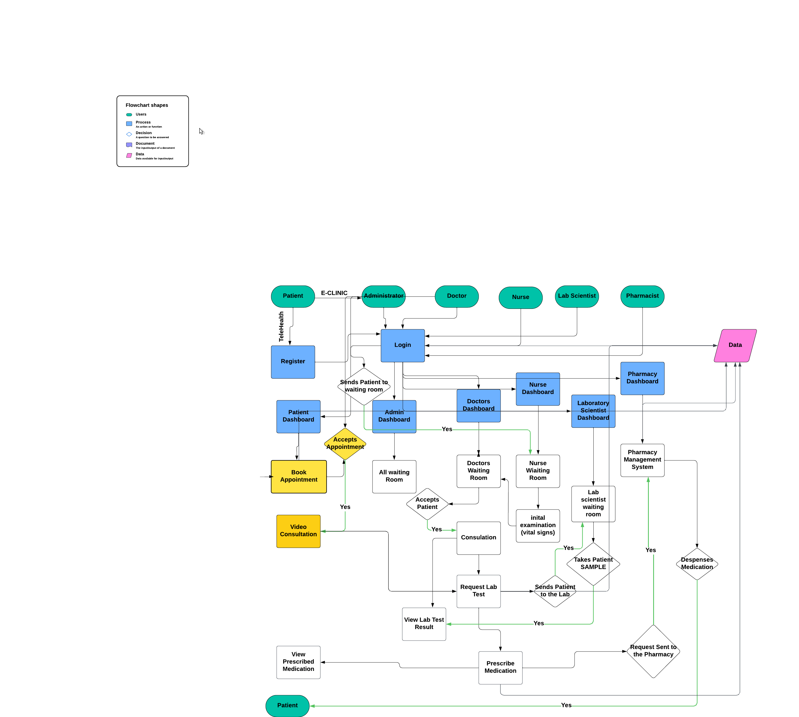

**Diagram 2.1: Flow Chart of the integration of Telehealth and E-clinic Platform for Patient Management**

## 2.5 Data protection and privacy

Data protection and privacy are crucial for any healthcare platform. The General Data Protection Regulation (GDPR) and similar regulations across the world establish high standards for patient data security. Appari and Johnson's (2010) research highlights the need of good security measures in preventing data breaches and protecting patient confidentiality.

To secure patient data and preserve confidence in the system, the proposed platform would use state-of-the-art security methods such as end-to-end encryption, user authentication, and compliance with applicable data protection legislation.

2.6 User Interface Design  
The design of user interfaces in digital health systems is crucial to user adaptation and satisfaction. Zhang and Walji (2011) said that usability and ease of navigation are important aspects in determining the success of health information systems. Poorly designed interfaces can cause user frustration, errors, and less efficiency.   
The proposed platform would prioritise user-centric design concepts, resulting in clear and understandable interfaces for patients, healthcare practitioners, and other stakeholders. This method will increase user engagement while also ensuring that the platform satisfies the demands of all users efficiently.

## 2.7 Related Work and Existing Platforms

Several telehealth and E-clinic platforms are now in use, each with unique strengths and limitations. Platforms such as Teladoc and Amwell provide complete telehealth services, however they may lack seamless connection with EHR systems. Traditional EHR systems, like as Epic and Cerner, provide strong patient data management but may not completely enable telehealth capabilities.The proposed platform seeks to close these gaps by providing an integrated solution that incorporates the capabilities of telehealth and E-clinic platforms while also addressing their limitations. By doing so, it hopes to give a more comprehensive and efficient approach to patient management and healthcare delivery.

2.8 Conclusion  
The integration of telehealth and E-clinic functions represents a huge step forward in digital healthcare, providing a holistic solution to improve healthcare accessibility, efficiency, and outcomes. The research emphasises the potential benefits of such integration, which include increased continuity of care, patient satisfaction, and healthcare delivery.   
The proposed platform would build on existing research and development efforts, addressing current difficulties with a secure, user-friendly, and complete solution. By integrating cutting-edge technology and best practices, the platform promises to give significant advantages to patients, healthcare providers, and other stakeholders, ultimately contributing to the development of global health systems.

# Chapter 3

# Technologies and Resources

## 3.1 Major Resources Required

The Integrated Telehealth and E-clinic Platform for Patient Management will require a combination of hardware, software, and human resources. Here is a full breakdown of the major resources required:   
  
3.2 Hardware  
**1. Servers:** To host the platform and securely store patient data.

2**. Network infrastructure** includes high-speed internet connections, routers, and firewalls to enable reliable and secure access.  
**3. End-User Device:** Patients and healthcare providers can access the platform via computers, tablets, or smartphones.

3.3 Software & Tools  
**1. Development Environment:** Integrated Development Environments (IDEs) include Visual Studio Code.   
**2. Version Control System:** Git allows for version control and collaboration.  
**3. Database Management Systems:** MySQL handles data storage and retrieval.

4. **Web Servers**: Apache serves web applications.

5. **Security tools:** SSL certificates, encryption libraries, and security auditing tools are used to assure data security.  
6. **Test Tools:** Selenium for automated testing, PHP UNIT for unit testing, and LoadRunner for load testing.

3.4 Human Resources  
**1. Project Manager:** To manage the project and ensure timely completion.  
**2. Software developers:** Skill in JavaScript, PHP, HTML, CSS, MySQL, and other related technologies.  
**3. UI/UX Designers:** Design intuitive and user-friendly interfaces.  
**4. Database Administrators:** To manage and maintain a MySQL database.  
**5. Security experts:** Implement and audit security measures.  
**6. QA/test engineers:** To evaluate the platform's functionality, speed, and security.  
**7. Healthcare professionals:** To give insight and ensure the platform satisfies clinical requirements.

**Organisational Chart**

**Diagram 3.1: Organisation Chart of Integrated Telehealth and E-clinic platform for Patient Management**

## 3.5 Technologies to be used

The platform will be developed using a mix of front-end components, back-end, and database technologies. Here is a thorough list of the technologies that will be used.

## 3.5.1 Front End Technologies

1. **HTML5:** For structuring the web pages.
2. **CSS3:** Used to style and layout web pages.
3. **JavaScript:** To make web pages more interactive and dynamic.
4. **Bootstrap:** For responsive design and faster UI development.

## 3.5.2 Back-End Technology

**PHP:** For server-side scripting and managing business logic.

## 3.5.3 Database

**MySQL:** For relational database administration and storage of patient records, appointment

details, and other pertinent information.

## 3.5.4 Security Technologies

1. **SSL/TLS:** To encrypt data transferred between the client and server.
2. **Firewall and Intrusion Detection Systems (IDS)**: For protecting the server infrastructure.

## 3.6 Data Sources

The platform's data will come from multiple sources:

1. **Patient Input:** Patients provided information during registration and consultations.
2. **Healthcare providers:** Medical records, prescriptions, treatment plans, and notes are entered by physicians, nurses, and other healthcare professionals.
3. **Diagnostic Laboratory:** The test results and diagnostic reports that are uploaded by laboratory technicians.
4. **Pharmacies:** Prescription fulfilment and medication adherence data.

3.7 Integration of Third-Party Services  
To enhance the platform's capabilities, it will integrate with a variety of third-party services.   
1. **Payment Gateways:** Integration with payment processors such as Stripe or PayPal to facilitate online payments.  
**2. Cloud services**: For scalable cloud infrastructure and services, use AWS, Google Cloud, or Microsoft Azure.

‘

# Chapter 4

# Method and Work plan

4.1 Methodologies   
To accomplish the aims and objectives of the Integrated Telehealth and E-clinic Platform for Patient Management, the project will use agile development methodologies. This technique enables for iterative development, continual feedback, and gradually improvements, ensuring that the platform meets its users' demands successfully.   
  
**Major Phases of the Project**

1. Requirement Gathering and Analysis
2. System Design
3. Development
4. Testing
5. Deployment
6. Maintenance and Support

## 4.2 Milestones and deliverables

|  |  |  |
| --- | --- | --- |
| **Phases** | **Milestone** | **Deliverables** |
| **Phase 1:** Requirement Gathering and Analysis (Weeks 1–4) | Complete the requirement analysis. | 1. Requirement Analysis Report 2. Project Plan 3. Stakeholder Approval 4. Background research / current state of the art 5. Discussion on ethics, data protection, and safety. |
| **Phase 2:** System Design (weeks 5–8) | Completed system design | 1. System Architecture Diagram 2. Database Schema Design 3. User Interface Design Prototypes |
| **Phase 3:** Development (Weeks 8-15) | Finalisation of core module development | 1. Developed modules for secure video calls and chat 2. Implemented EHR system 3. Online test results access feature 4. Initial patient management module 5. Pharmacy management 6. Data security and privacy compliance features |
| **Phase 4:** Testing (Week 15-16) | Completion of testing | 1. Develop Test Plan and Test Cases 2. Conduct Testing and Bug Fixing 3. Conduct User Acceptance Testing (UAT) |
| **Phase 5:** Deployment (Weeks 17) | Successful platform deployment | 1. Deployed Platform 2. User Training Materials 3. Technical Documentation |
| **Phase 6:** Maintenance and Support (Ongoing) | Continuous support and maintenance | 1. Patches and Regular Updates 2. User Support and Issue Resolution 3. Performance monitoring reports |

Table: 4.1 Milestones and Deliverables of the Integration of Telehealth and E-clinic Platform for Patient Management

## 4.3 Additional Documentation

1. **Introduction and background:**
2. Background research / present state of the art
3. Contextualising the problem
4. Discussion on ethics, data protection, and safety.
5. **Literature Review:**
6. Initial review during proposal phase.
7. Detailed literature review as the project progresses.
8. **Contribution Chapters:**
9. Method: An explanation of how the project was completed, including the selection of methods, techniques, and technology.
10. Main outputs or deliverables include design solutions, implementation, and testing.
11. **Discussion:** Critical evaluation, explanation of recommendations, and process review.
12. **Conclusions and further Work:** A summary of findings and ideas for further work.

## 4.4 Major Contingencies

1. **Technical Challenges:** Unexpected technological challenges arise during development or integration of third-party systems.

**Mitigation:** Schedule buffer time and ensure that technical reviews are conducted on a regular basis.

1. **Regulatory changes:** Changes to healthcare data protection legislation and regulations.

**Mitigation:** Monitor regulatory developments on a regular basis and swiftly implement any necessary modifications.

1. **Resource Availability:** Lack of essential individuals or resources.

**Mitigation:** Cross-train team members and maintain a flexible resource allocation strategy.

1. **Stakeholder Feedback:** Delays are caused by excessive input or additional requests from stakeholders.

**Mitigation:** Maintain open communication lines and manage expectations by providing regular updates.

**Gantt Chart and Schedule**

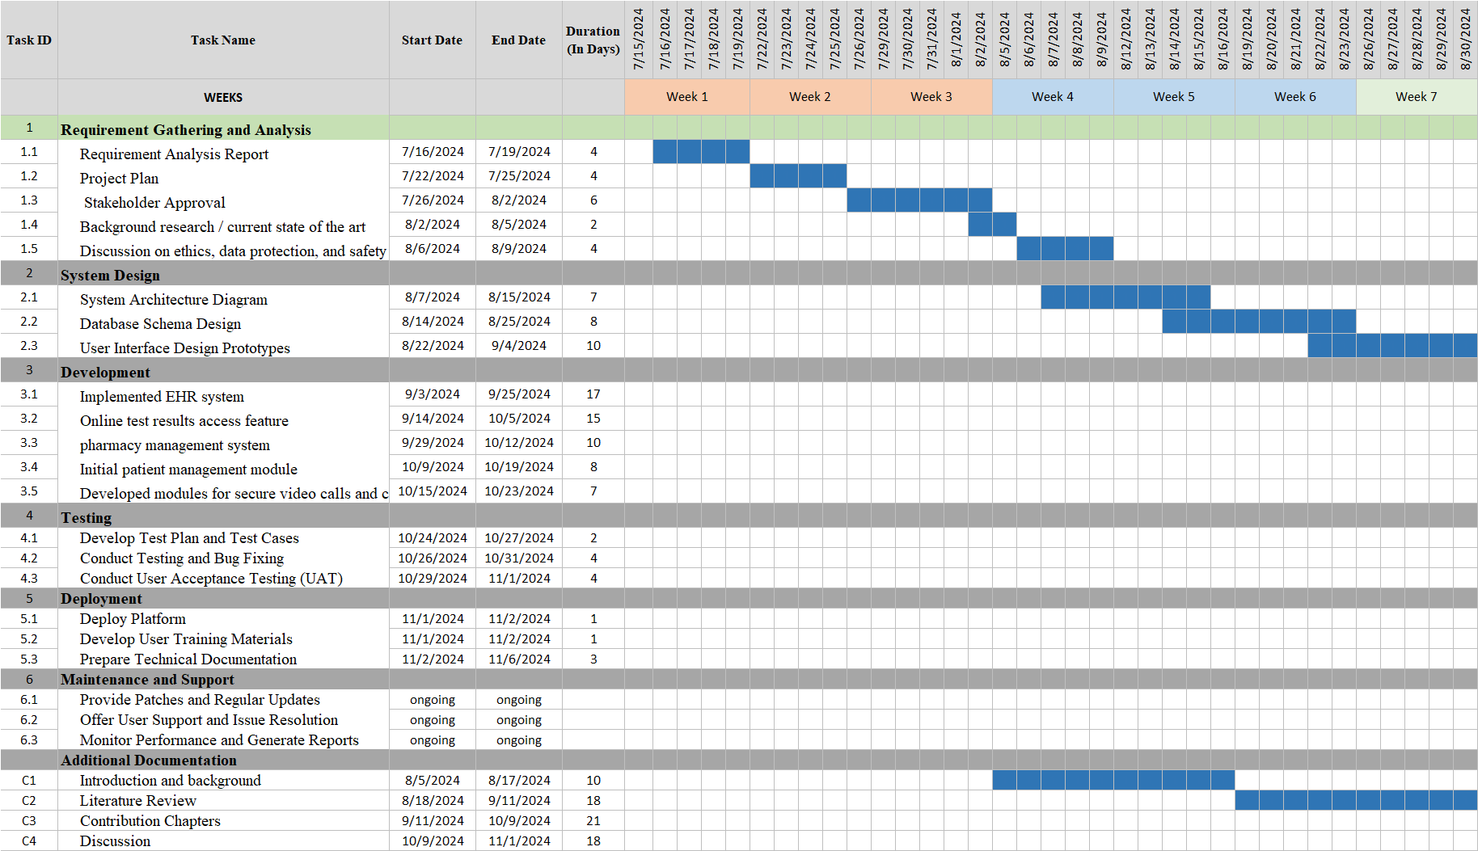

**Diagram 4.1a: Gantt chart of the Integration of Telehealth and E-clinic Platform for Patient Management**

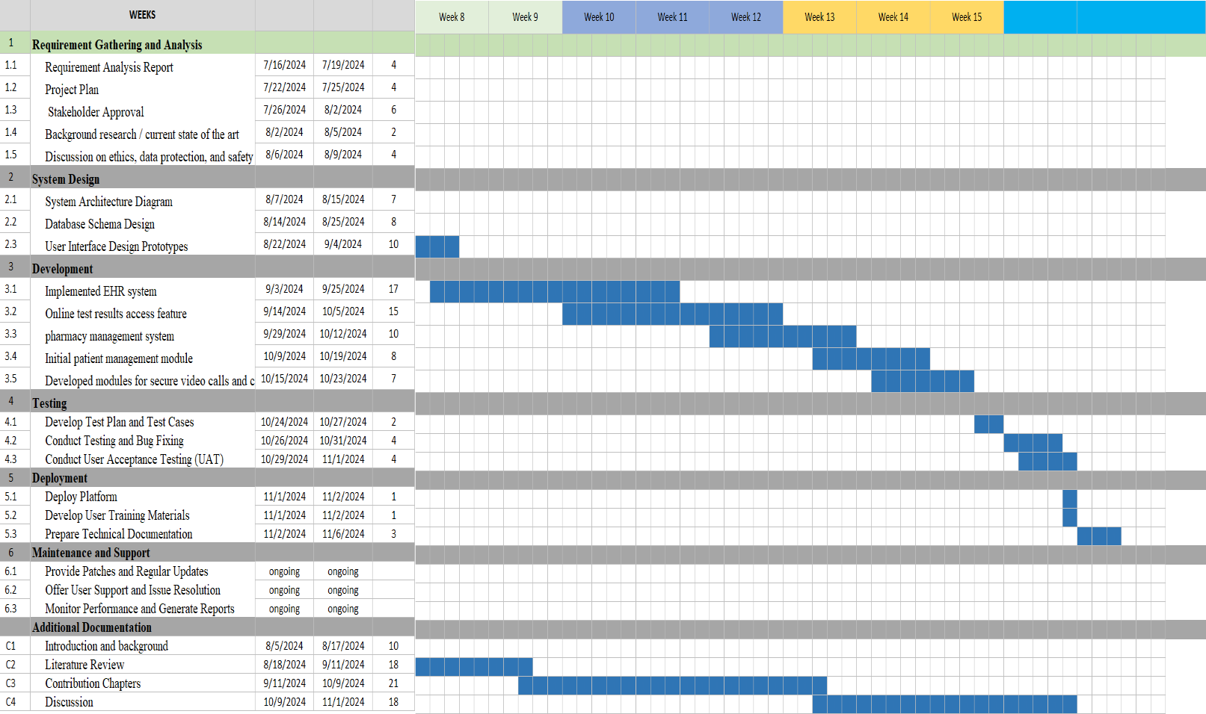

**Diagram 4.1b: Gantt chart of the Integration of Telehealth and E-clinic Platform for Patient Management**

## 4.5 Risk Analysis

|  |  |  |  |
| --- | --- | --- | --- |
| **Types of Risk** | **Risk** | **Impact** | **Mitigation** |
| 1. **Technical Risks** | Integration problems with third-party services and APIs. | **High**  Might cause project delays and functioning issues. | Conduct comprehensive testing and have backup plans in place. |
| 1. **Security Risk** | Potential data leaks and security flaws. | **High**  May jeopardise patient data and platform integrity. | Implement strong security measures and carry out frequent security assessments. |
| 1. **Regulatory Risk** | Non-compliance with changing healthcare rules. | **Medium**  May result in legal troubles and sanctions. | Keep up with regulatory developments and maintain continuing compliance. |
| 1. **Resource Risk** | The loss of important individuals or delays in resource availability. | **Medium**  Sized projects may have an impact on timetables and deliveries. | Maintain a flexible resource allocation strategy, and cross-train team members. |
| 1. **Stakeholder Risks** | Changes in stakeholder requirements and feedback. | **Medium**  Potentially result in scope creep and project delays. | Maintain expectations by providing regular updates and clear communication. |

**Table 4.2 Risk Analysis of the Integration of Telehealth and E-clinic Platform for Patient Management**

**Project Prototypes**

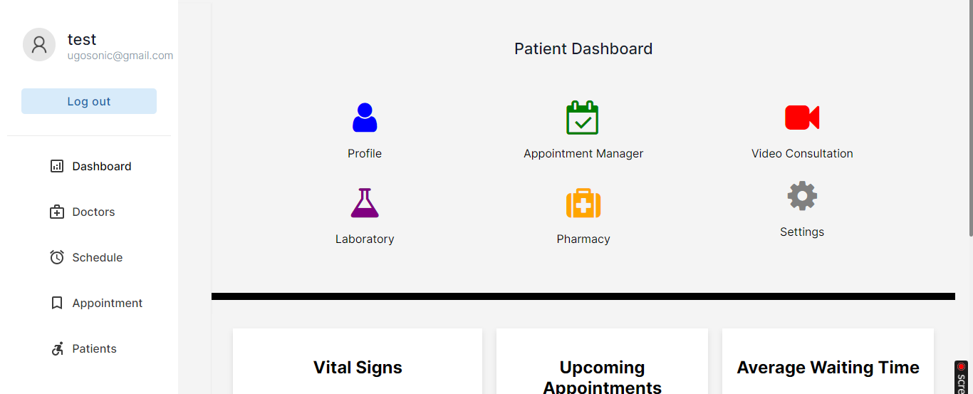

**Diagram 4.2: Patient Dashboard**

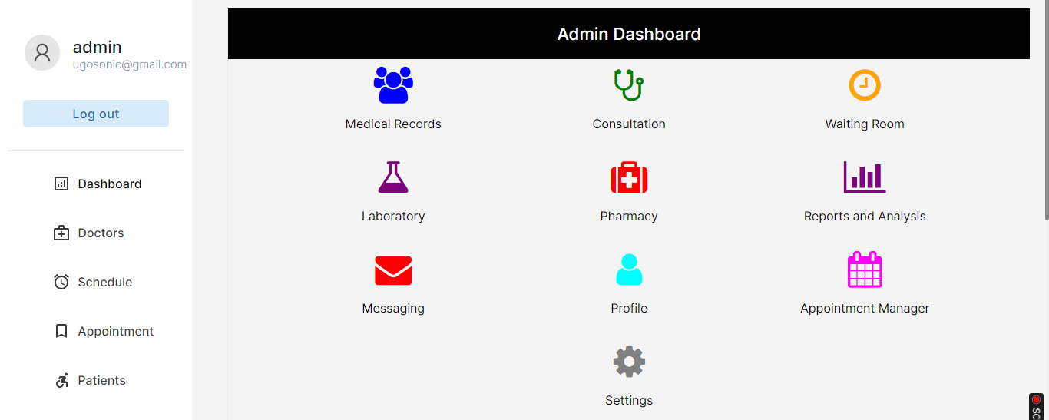

**Diagram 4.3: Admin Dashboard**

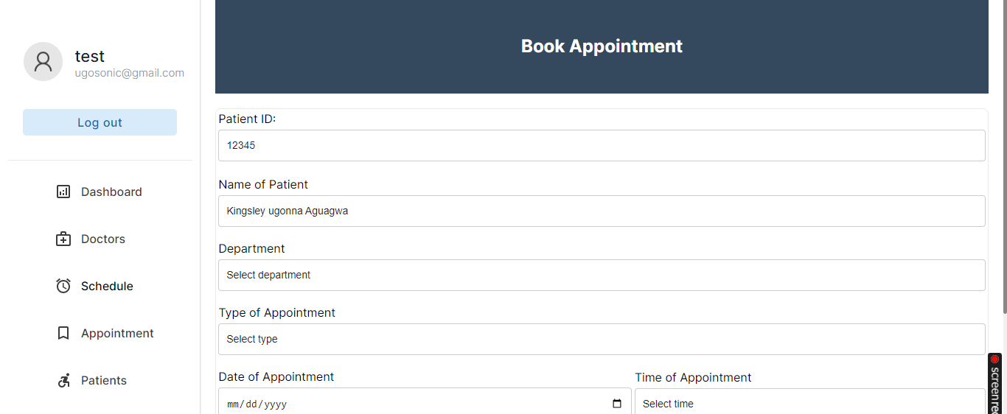

**Diagram 4.4 Book Appointment Interface**

# CHAPTER 5

# Ethical, Legal, Data Protection, and Safety Aspects

5.1 Ethical Perspectives  
Creating an Integrated Telehealth and E-clinic Platform for Patient Management requires careful consideration of many ethical considerations to guarantee that the project adheres to the highest standards of medical ethics. Key ethical considerations include:

**1. Patient Autonomy:** The platform must respect patient autonomy by giving clear information regarding telehealth services, permitting informed consent, and allowing patients to make their own healthcare decisions.  
**2. Confidentiality**: Maintaining the confidentiality of patient information is critical. To prevent unauthorised access and breaches of sensitive health data, the platform must adopt comprehensive security measures.  
**3. Beneficence and non-maleficence:** The platform should aim to generate positive results for patients while minimising possible harm. This includes maintaining the authenticity of medical information, delivering dependable healthcare services, and avoiding any behaviours that may harm patient health.  
4. **Equity and Access:** The platform should guarantee that all patients, regardless of socioeconomic class or location, have access to healthcare, including telehealth services.

## 5.2 Legal aspects

The implementation of an Integrated Telehealth and E-clinic Platform involves addressing several legal issues, including:

1. **Compliance with Healthcare standards:** The platform must follow both national and international healthcare standards, such as the Health Insurance Portability and Accountability Act (HIPAA) in the United States and the General Data Protection Regulation (GDPR) in the EU. These regulations provide guidelines for the protection of patient data and privacy.
2. **Licencing and Accreditation:** Healthcare practitioners that use the platform must be properly licenced and accredited to practise telemedicine. The platform should contain procedures for verifying healthcare practitioners' qualifications and ensuring compliance with licencing laws.
3. **Jurisdictional Issues:** Telehealth services sometimes cross geographical boundaries, creating jurisdictional issues. The platform must address legal concerns of cross-border healthcare delivery, such as differing standards of care, liability, and payment rules.
4. **Liability and malpractice:** Clear guidelines must be addressed via the establishment of clear norms and processes. This involves defining the scope of services offered, obtaining informed consent, and maintaining accurate documentation of patient contacts.

## 5.3 Data Protection Aspects

Patient data security is a vital component of the platform, requiring strong safeguards for sensitive information. Important data protection considerations include:

1. **Data Encryption:** To prevent unauthorised access, all patient data should be encrypted both in transit and at rest. This guarantees that even if data is intercepted, it is unreadable by unauthorised persons.
2. **Access Controls:** Implementing strong access controls is critical to ensuring that only authorised people may access patient data. This includes putting in place multi-factor authentication, role-based access controls, and performing regular access log audits.
3. **Data minimization:** The platform should follow the data minimization principle, gathering just the information required to provide healthcare services while minimising the preservation of unnecessary data.
4. **Data Breach Response:** Creating a thorough data breach response strategy is critical for dealing with possible security problems. This includes protocols for identifying, reporting, and mitigating data breaches, as well as alerting affected patients and regulatory agencies.

## 5.4 Safety considerations

Ensuring the safety of patients and healthcare professionals is an important factor in platform development. Key safety features include:

1. **Clinical Safety:** The platform must verify that telehealth services adhere to clinical safety guidelines. This includes implementing evidence-based guidelines, assuring the accuracy of diagnostic instruments, and teaching healthcare practitioners on how to use telehealth technology.
2. **Technical Reliability:** The platform will be built to be highly reliable and available, reducing the likelihood of technical failures that might disrupt patient care. Regular maintenance, testing, and upgrades are required to guarantee the platform's stability.
3. **Emergency Protocols:** Clear guidelines will be created to handle medical crises during telehealth consultations. This includes processes for referring patients to appropriate emergency services and maintaining continuity of treatment.
4. **Patient Education:** Patients should be taught how to utilise the platform safely and efficiently. This contains tips for scheduling telehealth consultations, utilising medical equipment, and recognising the limitations of telehealth services.

## Conclusion

This project presents an Integrated Telehealth and E-clinic Platform for Patient Management, which aims to overcome inefficiencies in current healthcare systems by improving accessibility, efficiency, and cost effectiveness. Patients, healthcare providers, administrators, insurance companies, and policymakers are among the most important stakeholders. The platform aims to improve patient care by combining telehealth and e-clinic services with electronic health records (EHRs), which will include comprehensive telehealth capabilities, increased patient management tools, and strict data security measures. The project uses agile approaches to promote continuous improvement and stakeholder interaction, with an emphasis on ethical, legal, and safety issues to assure high patient care standards. This complete platform promises to transform patient management and healthcare delivery, benefitting all parties.

## References

Adler-Milstein, J. & Jha, A. K., (2017) HITECH act drove large gains in hospital electronic health

record adoption*: Health Affairs*, 36(8), pp. 1416-1422.

Appari, A. & Johnson, M. E., (2010) Information security and privacy in healthcare: current state

of research. *International Journal of Internet and Enterprise Management*, 6(4), pp. 279-314.

Buntin, M. B., Burke, M. F., Hoaglin, M. C. & Blumenthal, D., 2011. The benefits of health

information technology: a review of the recent literature shows predominantly positive results. *Health Affairs*, 30(3), pp. 464-471.

Kruse, C. S., Krowski, N., Rodriguez, B., Tran, L., Vela, J. & Brooks, M., (2018). Telehealth and

patient satisfaction: a systematic review and narrative analysis. *BMJ Open*, 8(8), e020388.

Sood, S., Mbarika, V., Jugoo, S., Dookhy, R., Doarn, C. R., Prakash, N. & Merrell, R. C., (2007).

What is telemedicine? A collection of 104 peer-reviewed perspectives and theoretical underpinnings. *Telemedicine and e-Health*, 13(5), pp. 573-590.

Zhang, J. & Walji, M. F., (2011). TURF: Toward a unified framework of EHR usability. *Journal*

*of Biomedical Informatics*, 44(6), pp. 1056-1067.